**Pylint**

Pylint is SCA tool for code analysis it checks the code for errors and rates the code in comparison with coding standard it looks for code smells and certain types of bugs. Below is example of running pylint on my code and received 8.06 out of 10 for rating which shows several issues in the code, including lines exceeding the recommended length of 100 characters, missing docstrings for functions and the module, redefined outer variables, unnecessary else statements, and improper import order. These issues can affect code readability and maintainability, and should be addressed to improve code quality.

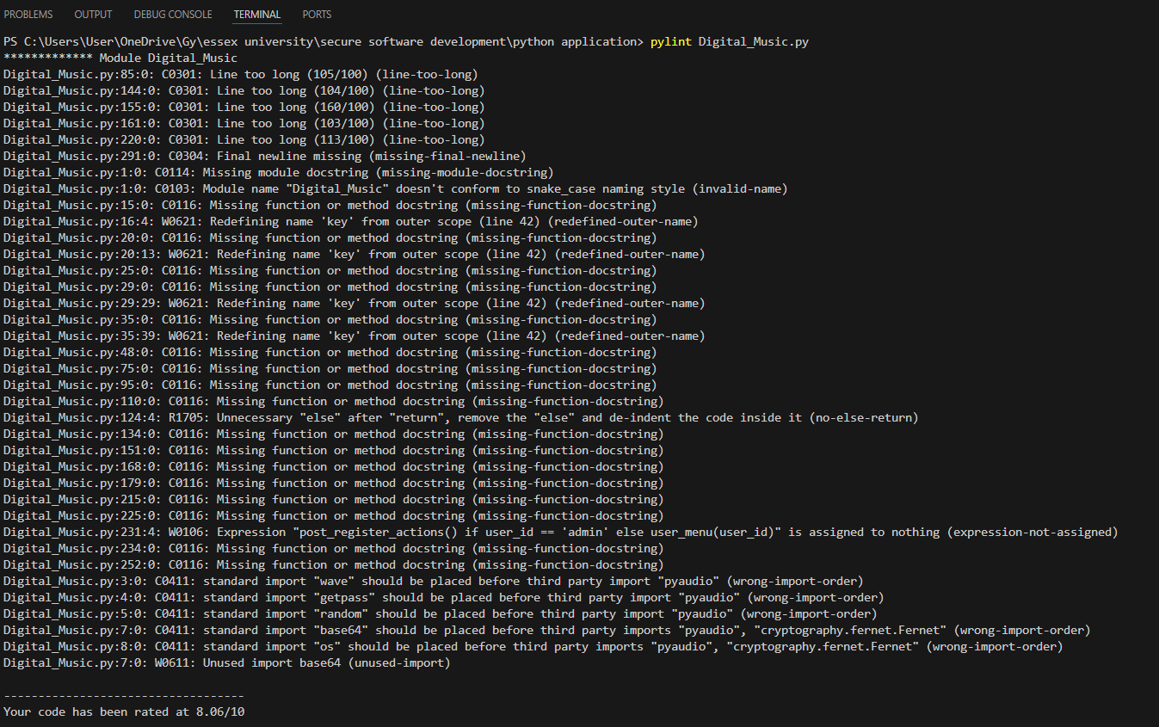

**Bandit**

Bandit is security tool to find most common security issues in python. The Bandit report highlights two security concerns in the code. First, a hardcoded password (admin123) was detected, which poses a security risk as it can be easily compromised. Second, the use of the random module for generating security-sensitive values (e.g., ratings) is flagged, as it is not suitable for cryptographic purposes due to its lack of randomness.

